
Report Designer
Contents
Project Layout 3
Application Configuration 3
appconfig.json 4
defaults.json 7
orms.json 8
runreportconfig.json 8
Getting Started 8
Login 8
Report Group Hierarchy 9
Setting Default Preferences 10
Create a New Report 11
Common Report Object Operations 12
Select an Object 12
Resize an Object 12
Moving an Object 12
Editing an Object 13
Text Align Multiple Objects 13
Align Multiple Objects 13
The Report Design Panel 15
Application Toolbar 15
Page Sections 15
Page Design Scroll 15
Adding Report Objects 16
Current Date 16
DB Data 17
Image 21
Chart 22
Label 26
Link 27
Email 28
Page Number 28
Shape 29
Running the Report 30
Saving a Report 32
Load an Existing Report 32

The Report Designer is a React web application designed to work in concert with the the Query Designer and Simple Node ORM. The Report Designer allows the user to create, save and run formatted WYSIWYG style reports backed by Query Designer queries.

Project Layout
The react/node project layout is shown below.

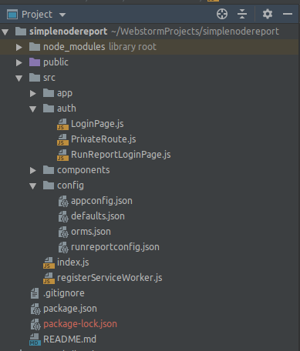

security

ui components
configuration

The project is available on github at:

https://rbtucker@github.com/rbtucker/simplenodereport.git

Application Configuration
Application configuration is handled in 4 files:
- appconfig.json – This is main application configuration file. In this file you can setup display text for UI components, available colors for color selection controls and various defaults for report designer functionality.
- defaults.json – this defines the default settings for a report – margins, font, orientation, document size etc.
- orms.json – this contains connection information for the Simple Node Orm installations that the Report Designer can connect to.
- runreportconfig.json – this defines settings used by the runtime report.

appconfig.json
Below is a code snippet from an example appconfig.json followed by a description of available settings:

{
"textmsg": {
"logintitletext": "Simple Node Report",
"selectdata": "Select Data",
"displayformat": "Display Format",
"addreport": "Add Report",
"addobject": "Add Report Object",
"loaddocument": "Load Report",
"deletedocument": "Delete Report",
"setupmenuname": "Setup",
"filemenuname": "File",
.
.
.
“demoMode”:true,
"pageSections": ["header", "body", "footer"],
"defaultReportAuthenticator": "DefaultAuthorizer",
"zoomFactor": 1.25,
"wheelIncrement": 25,
"documentSizeNames": ["LETTER", "LEGAL", "4A0", "2A0", "A0", "A1", "A2", "A3", "A4", "A5", "A6", "A7", "A8", "A9", "A10"],
"fonts": ["Arial", "Helvetica", "Times New Roman", "Courier New", "Courier", "Verdana"],
"fontSizes": [6, 7, 8, 9, 10, 11, 12, 13, 14, 15, 16, 17, 18, 19, 20, 21, 22, 23, 24,
25, 26, 27, 28, 29, 30, 35, 40, 45, 50],

name | description
textmsg | Configurable display text applied to the UI components in the designer.
demoMode | If true it is assumed that we are running in demo mode with designer in same docker container as orm.
pageSections | Report page section names/ids
defaultReportAuthenticator | Default javascript authenticator for Report Designer access.
zoomFactor | Zoom factor used in the Report Designer to enable easier report design. Defaults to 1.25 which shrinks the report layout slightly as compared to the live report.
wheelIncrement | Number of pixels to scroll when using the mouse wheel for verical scrolling the design. Defaults to 25.
documentSizeNames | Array of supported document sizes - "LETTER", "LEGAL", "4A0", "2A0", "A0", "A1", "A2", "A3", "A4", "A5", "A6", "A7", "A8", "A9", "A10"
fonts | Array of supported font names
fontSizes | Array of supported font sizes
fontWeights | Array of supported font weights
borderStyles | Array of supported standard css border styles
borderWidths | Array of supported border widths
defaultPreferenceNames | Array of key values for default preference settings - "marginLeft", "marginTop", "marginRight", "marginBottom", "fontFamily", "font", "fontSize", "documentSize", "reportName"
reportObjectTypes | Array of report object components that can be added to a report - "current date","dbdata", "image", "graph", "label", "link", "email", "page number", "shape"
shapes | Available shape components that can be added to a report - "rectangle", "ellipse", "horizontal line", "vertical line"
dateFormats | Array of JSON objects defining available date formats - for example:  {"format": "mm/dd/yyyy", "example": "01/21/2019"},
pageNumberFormats | Array of JSON objects defing available page number formats – for example:  {"key":"?.", "example": "1."},  When run “?” will be replaced by current page number
pageNumberLocations | JSON array of available locations where a page number object can be placed – for example:  {"key": "bm", "name": "bottom middle"},
dbObjectDisplayFormats | Each report will be associated with a backing query. The “dbdata” report object is designed to display the results of the query and can be in 2 formats – grid or name/value by row. A grid is your standard table with rows and columns. Name/value by row displays individual row columns vertically in the format:  columnName1 columnValue1  columnName2 columnValue2  In addition, each of the types above can be used as a page break initiatiator. The displayObjectFormats entry defines these 4 conditions as an array of json objects. For example:  {  "key": 1,  "display": "Grid"  },  {  "key": 2,  "display": "Grid with Page Break"  },
defaultDbObjectDisplayFormat | This is the key of the dbObjectDisplayFormat to use by default – 1, 2, 3, 4
defaulttablecellpadding | Default padding used for the dbdata grid
selectedObjectBorder | Border used to indicate that a Report Object is selected in the designer – defaults to:  "solid 1px red"
labelBorder | Border used to indcate a label report object type – defaults to:  "dotted 1px darkBlue"
activeObjectBorder | Border to indicate the report object under the current mouse position – defaults to:  "dotted 1px red"
defaultReportObjectRect | Default size and location of a newly added report object if not overridden.
resizeMargin | Width in pixels of position check for mouse resize operations.
moveOffset | Width in pixels that a mouse must move before a drag operation will be initiated
moveCursor | Cursor to use when dragging an object – defaults to “grabbing”
columnResizeCursor | Cursor to use when resizing a grid column – default to: "col-resize"
rowResizeCursor | Cursor to use when resizing a grid row – defaults to: "row-resize"
pointToPixelFactor | Constant to use when converting point to pixels for font width calculations – defaults to: 1.333
pointToPixelHeightFactor | Constant to use when converting point to pixels for font height calculations defaults to: 1.75
defaultTextColor | Default report text color – defaults to: “black”
defaultBackgroundColor | Default report background color – defaults to: “white”
dbDataTotalsSepartor | When displaying a dbdata grid object summary totals can be displayed. This is the separtor used between the data and the totals – defaults to the a line: "solid 0.025in black",
defaultFontWeight | Default report font weight – defaults to: 100
defaultColumnWidth | Default column width for dbdata grid column – defaults to: 75
keyMoveIncrement | Seleceted report objects can be moved by using the arrow keys – this is the number of pixels to move per click – defaults to 5
pageNumberPadding | Padding used when positioning the page number on the page. Page numbers are displayed on the top and bottom margin boundries.
defaultShape | Default shape for shape report objects – defaults to: “rectangle”
monthNames | Array of full month names used in the current date report object. "January","February","March",  "April","May","June","July","August","September",  "October","November","December"
colors | Array of available HTML colors to use in the color selection control.

defaults.json
{
"reportName": "new report",
"marginLeft": 0.5,
"marginTop": 0.5,
"marginRight": 0.5,
"marginBottom": 0.5,
"fontSize": 10,
"orientation": "portrait",
"fontFamily": "Arial,Helvetica,sans-serif",
"font": "Arial",
"documentSize": "LETTER"
}

orms.json
Report Designer supports multiple ORM installations. An example configuration for available ORMs is shown below. defaultUsername and defaultPassword are optional, if they exists they will auto-populate the associated login dialog fields.

[
{
"name" : "simple",
"url" : "http://localhost:8888/orm"
},
{
"name" : "kfs",
"url" : "http://localhost:8888/kfsorm", "defaultUsername" : "user", "defaultPassword" : "pass"
}
]

runreportconfig.json
This is a subset of the appconfig.json used when a live report is run:
{
"textmsg": {
"logintitletext": "Run Report",
"reportlogin": "Login",
"username": "Username:",
"password": "Password:",
"login": "Login",
"passwordrequired": "Password is required",
"usernamerequired": "Username is required",
"authenticating": "Authenticating...",
"runningreport": "Running <1> report...",
"paramentrytitle": "Parameter Entry",
"reportcancelled": "Report cancelled",
"reportrunner": "Report Runner"

},
"pageSections": ["header", "body", "footer"],
"defaultReportAuthenticator": "DefaultAuthorizer",
"zoomFactor": 1.25,
"wheelIncrement": 25
}

Getting Started

Login
Pull up the application in the browser, select the desired ORM, enter Username and Password if required and click Login.

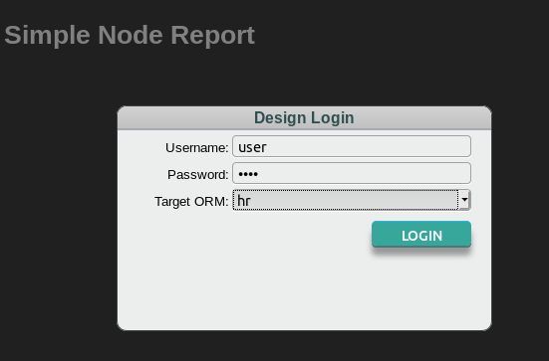

Once logged in you should see a screen similar to this:

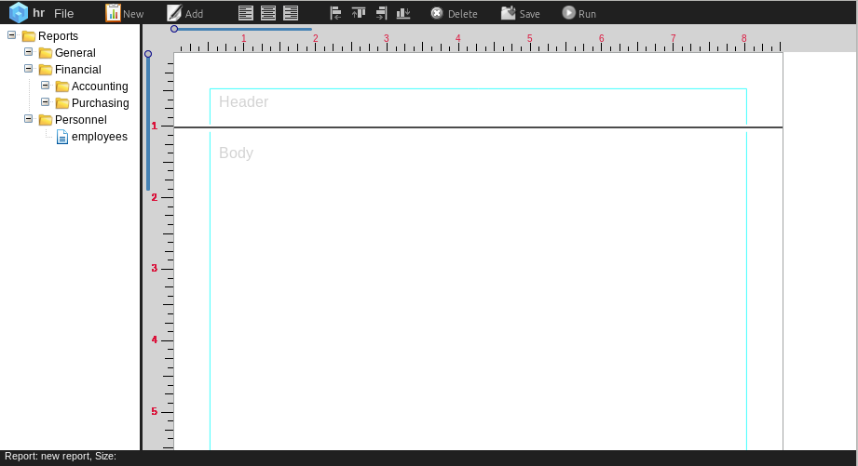

The left pane contains the document tree. The right pane contains the document design panel. Previously created report documents will display in the left pane -
“employees” is an example.

Report Group Hierarchy
The group hierarchy shown in the left panel above is defined at the ORM server level in file report-document-groups.json. For the example above the definition is:

{
"title": "Reports",
"key" : "grp0",
"isLeaf": false,
"children": [
{
"title": "General",
"key" : "grp1",
"isLeaf": false
},
{
"title": "Financial",
"key" : "grp2",
"isLeaf": false,
"children": [
{
"title": "Accounting",
"key" : "grp3",
"isLeaf": false
},
{
"title": "Purchasing",
"key" : "grp4",
"isLeaf": false
}
]
},
{
"title": "Personnel",
"key" : "grp5",
"isLeaf": false
}
]
}

Implementation specific hierarchy defintions can be created as desired.

Setting Default Preferences
Click the File menu item on the application toolbar then click Preferences from the dropdown menu to show the Default Settings panel.

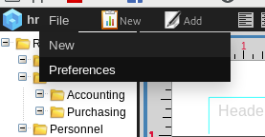

Set your desired default settings. These are what will pre-populate the report settings when you create a new report.
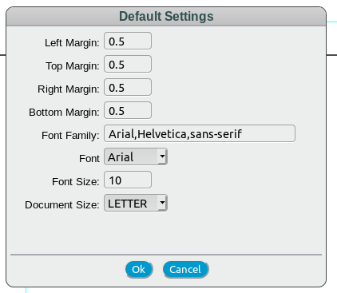

Create a New Report
From the application toolbar click the New report icon
to display the Add Report panel:
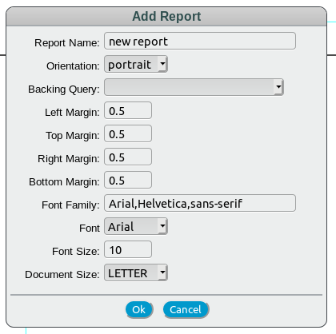

Enter an appropriate report name and select a backing query.

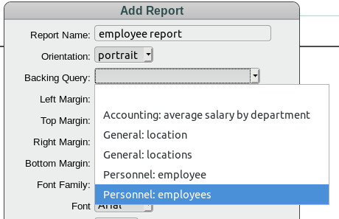

Make any other desired modifications to the report format and click Ok to start designing a new report.

Common Report Object Operations
When designing a report there a some common operations that select, move, resize and edit report objects. For this discussion we will use the “example label” in the header section shown below. Note that this label has the defined label border. This border is for development purposes only an to used to identify labels and will not display in active report.
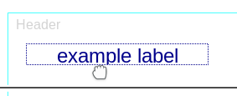

Select an Object
To select a report object press the CTRL key and left click the object with the mouse. The object will display the selected (defaults to red) border. To deselect the object CTRL click again. To deselect all selected objects press the ESC key.
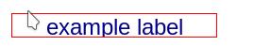

Resize an Object
Report objects can be resized in 2 ways:
- Hover the mouse over a border and when the resize cursor displays, drag the border

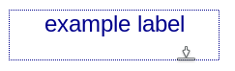

- Selected objects can be resized by holding down shift key and pressing the arrow keys. Resizing will be applied to all selected objects.
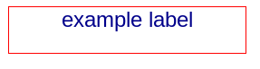

Moving an Object
To move a report object drag it with the mouse. A selected object can be moved with the arrow keys.

Editing an Object
To edit or delete an existing report object, right click on the object and select the desired option from the popup menu.

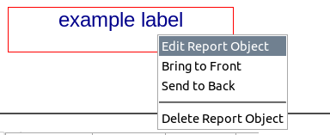

Text Align Multiple Objects
To set the text alignment on multiple objects, select the target objects:
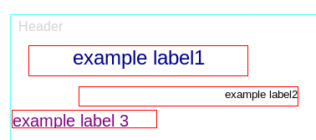

then click the desired alignment icon on the tool bar.
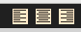

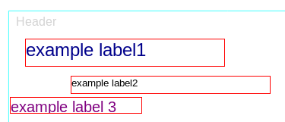

Align Multiple Objects
To align multiple objects, select the desired target objects. The selected objects will align to the associated border of the first selected object. Click the desired object align icon:

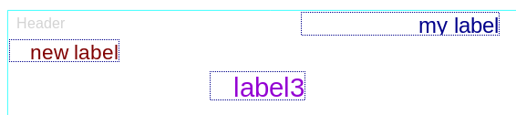

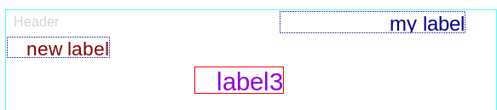

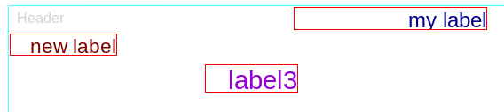

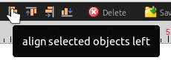

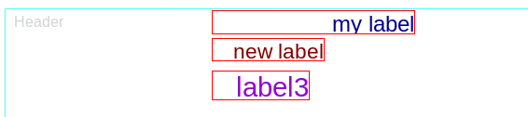

The Report Design Panel
After completing the steps listed in the previous section your are presented with an enabled report design panel formatted based on your selections. Key design panel components are desribed below.

Application Toolbar
The application toolbar provides the following functionality:

- Add new report
- Add report objects
- Text align on selected report objects
- Report object align
- Delete selected report objects
- Save report
- Run report
delete selected objects
add report object
run report
new report

text align selected objects
align selected objects
save report

Page Sections
The design panel is broken into 3 page sections – header, body and footer. These sections are resizable by moving the section separtor.
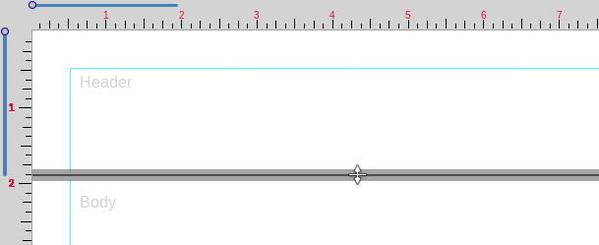

Page Design Scroll
Use the vertical and horizontal design scroll controls to scroll the report design:

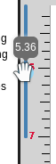

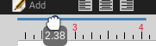

The mouse wheel can be used for vertical scrolling.

Adding Report Objects
To add a report object click the add report object icon
and select the desired object type from
the displayed list:

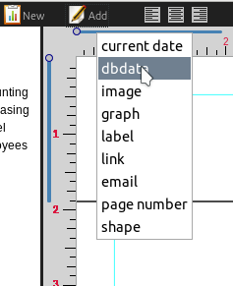

Current Date
To add a current date object to the report select current date from the add object dropdown.

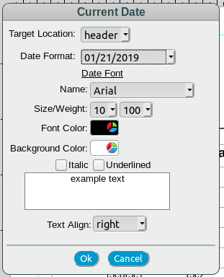
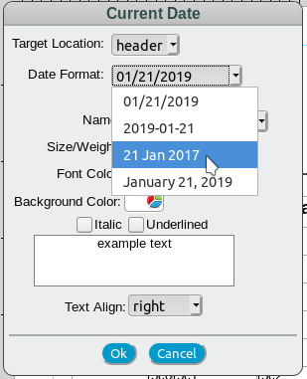

Select the report section, date format and set the font as desired then click Ok to add to the report.
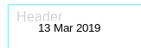

The current report run date will be inserted into this object at runtime.

DB Data
The dbdata report object is the report link to the backing query result data. An example of the object setup panel is shown below:

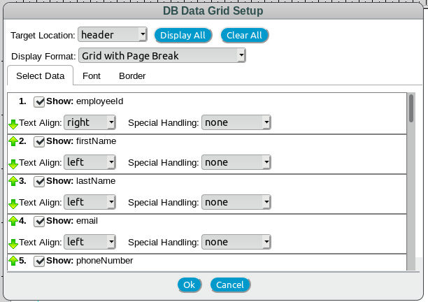
The Select Data panel allows the user to select, order and format result set data for the report object. By default, all available columns in the backing query are selected. The user can click the Display All and Clear All buttons to change all the column selections. Individual columns can be selected and deselected by clicking the Show checkbox. Column names are shown next to Show checkbox. The format will show the path to the column so more complex data from child objects are shown as an arrow delimited string – for example:

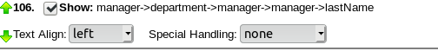

Selected column order can be adjusted by clicking the green arrows. Display Format allows the user to select how the data will be displayed on the report and how to control page breaks.

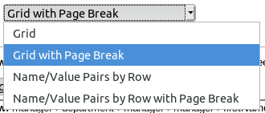

The selections are descibed below:
- Grid – displays a standard column/row table with the selected result set data. Column and rows are resizable via mouse.
- Grid with Page Break – displays column/row table and forces a page break when the report object display area is full. Column and rows are resizable via mouse.
- Name/Value Pairs by Row – displays a vertical Name Value list of row data. Each Name and value is an individual object which can be moved and resized as desired.
- Name/Value Pairs by Row with Page Break - displays a vertical Name Value list of row data and forces a page break after each row.

Below are examples of the Grid and Name/Value objects:
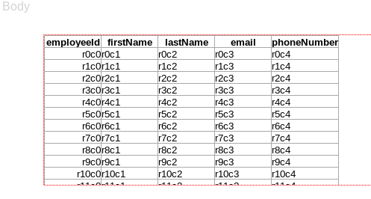

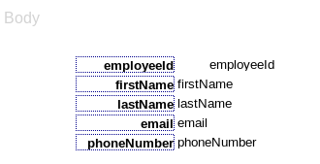

Special Handling can be applied to report columns.

For numeric fields the following options are available:

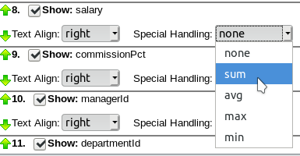

If selected, the numeric options will display on a Grid object in a totals line added at the end of the grid. The option will not be applied to the Name/Value pairs display type.

For text column types the following options are available:

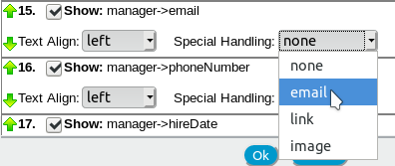

If selected, the text-based options will apply to the displayed data. For email and link options the text will used for an HTML anchor tag. For the image option, it will be assumed that the text is an image url and an HTML image tag will be created.

The Font and Border tabs allow the user to set header and data font and border properties for the displayed results:

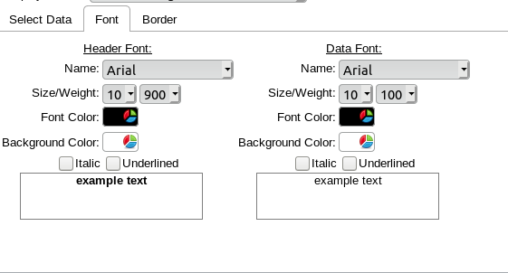

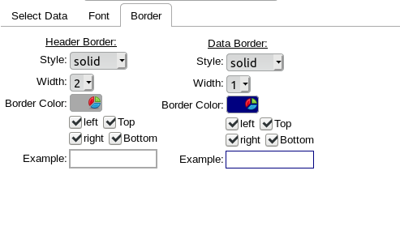

Image

Select image from the report object popup menu to add an image to the report.

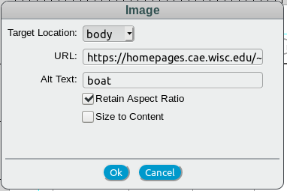

Select target page location, enter image URL, Alt text and click Ok to place image object on the report. The checkboxes support the following:

- Retain Aspect Ratio – if checked the image will retain the original aspect ratio and fit the report object rectangle based on the max/min sizes of the target rectangle.
- Size to Content – if checked the image will be placed in the report at the original size. If the report object size is smaller than the image size then only a portion of the image will be visible. If not checked, the image will be sized to the report object size.

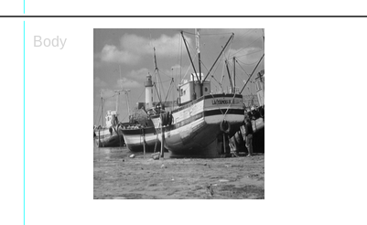

Chart
Basic charting functionality is implemented in the report designer using Chart.js. It is expected that the backing query puls data in a format that allows the chart functionality. In most cases this will be some sort of aggregate function based query with the appropriate group by for the category. Currently, the following chart types are supported:

- Bar
- Line
- Pie
- Doughnut

more chart types will be available in future versions.

To create a chart object select the desired chart type from the report object dropdown menu:

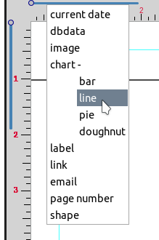

This will display the ChartSetupPanel:
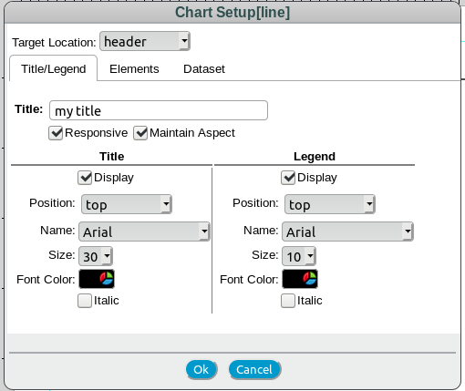

The chart setup panel contains the following tags:

- Title/Legend – title and legend configuration
- Elements – shown only for line and bar charts. For line charts allows for configuration of displayed data points. For line and bar charts allows text entry for axis name.
- Dataset – dataset configuration for the chart.

Elements Tab
The elements tab is shown below for the line chart:

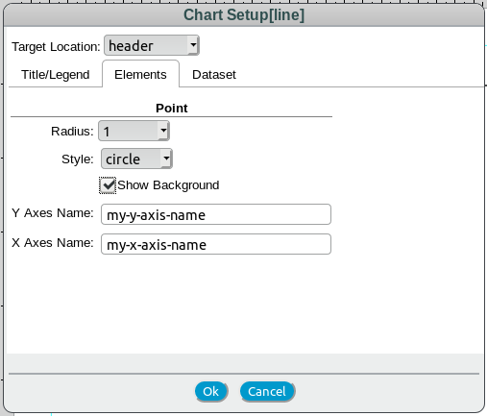

data point definition

fill under line

This is what the settings above will display on a line chart. The design display will be slightly different than the runtime display due to example data and example category labels.

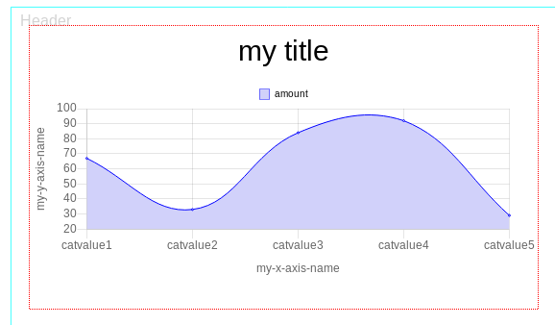

Below is an example of the runtime display:
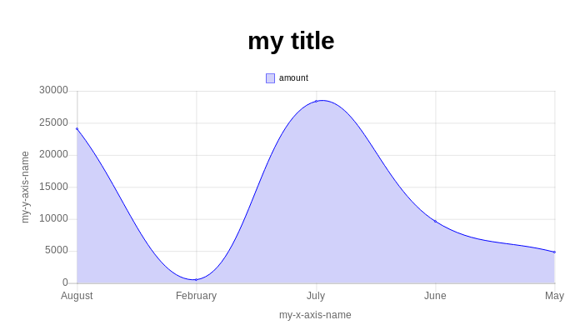

Dataset Tab
Below is the Dataset tab for the chart above. The category selection is the column selection used for the X-axis and the Data is the column selection for the Y-axis values. Bar and line charts support multiple data axis selections. The color selection will be the bar/line color. The label entry will be the text for the legend. The width selection will set the line width for the line column.

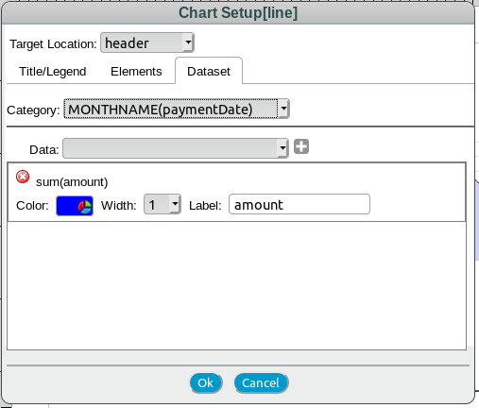

Label
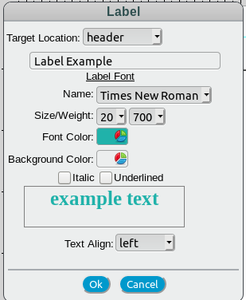
To create a label object select label from the report object dropdown menu:
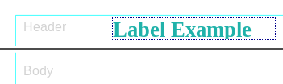

Link
To create a link, select link from the report object dropdown:

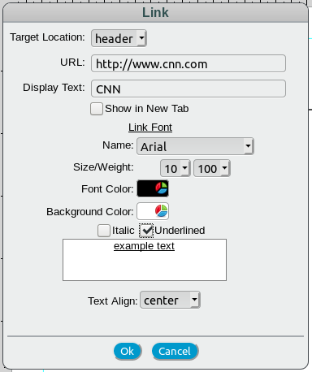

Select target location and desired font format. If you would like the contents of the URL to display in new tab when clicked, check the Show in New Tab checkbox.
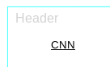

Email
Email is very similar to the link example above. Select email from the report object dropdown and choose your desired setting.

Page Number
To add a page number to report select page number from the report object dropdown:
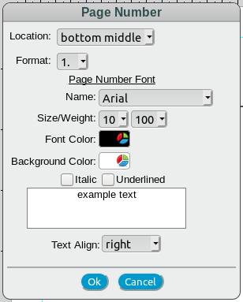

Select the page number location, format and desired font format then click Ok to add to the report. Available locations and formats are shown below.:

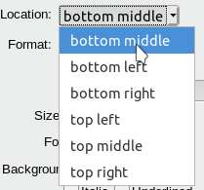
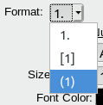

When the report is run the current page number will be placed in the object.
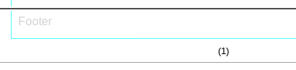

Shape
To add a shape to the report select shape from the report object dropdown:

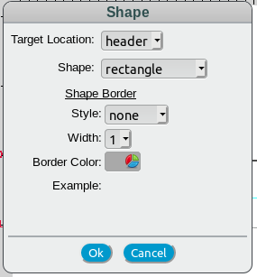

Select target location, desired shape and font format then click Ok to add to report.

The available shapes are shown below:

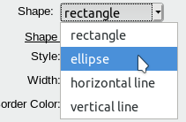
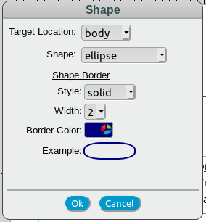
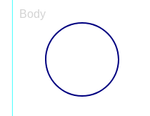

Running the Report
For test purposes the designed report can run from the designer by clicking the Run icon on the toolbar. So if we design a report something like this:

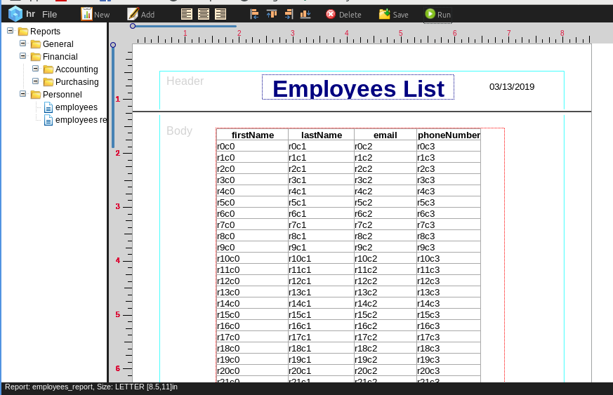
and click the run button we will get something like this:

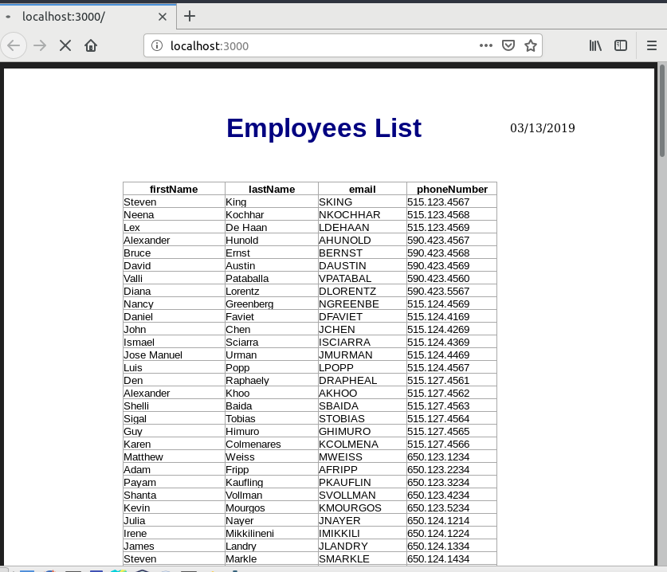
If runtime input parameters are required an input panel will display:
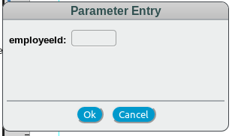

To run reports standalone you would call a url similar to the following:

http://<reportserver>/runreport/<ormid>.<groupname>.<reportname>

for example:

http://localhost/runreport/hr.grp5.employees

User login and/or parameter entry panels will display if required.

Saving a Report
To save a report click the save icon to display the Save Document panel:
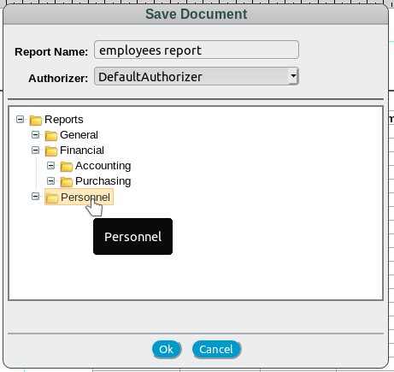

Update report name and authorizer if desired then select group for the report and click Ok to save.

Load an Existing Report
To load an existing report left click the desired report in the report tree and select Load Report from the popup menu:


